**LAB 2**

Task 2

* Step 2:



* Step 3:

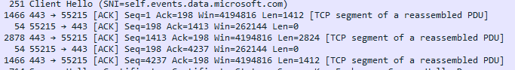

|  |  |  |
| --- | --- | --- |
|  | TCP or UDP | Reasons |
| Reliability and Connection  Establishment | TCP | TCP establishes a connection between the sender and receiver before data is sent. |
| Data Integrity and Ordering | TCP | TCP ensures that all data sent is received accurately and in the correct order |

|  |  |  |
| --- | --- | --- |
|  | TCP | UDP |
| Use cases | Email  File transfer  Secure communication | Online gaming  Streaming media  Real time communication |
| Performance | Connection Establishment Flow Control and Congestion Control | Connectionless  No Acknowledgments |